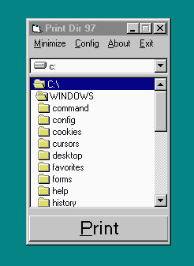

Print Dir 97

Copyright 1997
Jack L Crump

This program created entirely using Visual Basic 4.0.
Why? Windows 95 does not provide a simple way to print the conents of any directory. I find it is often very helpful to be able to. You can do it fairly easy from DOS and you can even fake Windows 95 into doing it. You won’t have long filenames, but it works…. It would have been so easy to have a Print command under the Explorer File menu. Anyway out of this need I decided to write this little program.

How? Simply run the program. Select the directory or drive that you wish to print the contents of and mash the print button. It will print using your Windows 95 default printer. Currently version 1.0 does not sort dirs and files. It will also not print graphics. Future versions may support these features.

Print Dir 97 was programmed in Visual Basic 4.0 in about 3 hours. It will ONLY run under Windows 95. The program does all that I need of it. It may appear to be a bit rough. The program will create a entry in your registry to store its configuration settings. Other than that it is completely non-intrusive. This program has been tested on various computers.

Legal Mumbo Jumbo Although every attempt was made to make this program safe and error free, by using this software you agree to hold the author (me) harmless should the program damage your computer or cause data loss. In fact, you agree to hold me harmless from anything that ever happens to you, for the life of the program or the life of the user, whichever is longer. Visual Basic and Windows 95 are Copyrighted and Trademarks of Microsoft.

Although this program is FAR from finished…It does everything that I want it to. If you would use it or would like to see more features added. Drop me an email. If I find enough people actually USE this program…I just might finish it….
\
mailto:jlcjr@worldnett.att.et

